Harvesting Energy from Tree Trunks

James D. Stevens

University of Washington at Tacoma, UTW   
School of Engineering and Technology

Tacoma, WA USA

jamesssf@uw.edu

***ABSTRACT:*  With the coming advent of smart devices, remote monitoring and long-range radio communication, there has been an increasing interest in alternative power sources and energy harvesting techniques to prolong indefinitely the smart devices life. One of these alternatives is to take advantage of the Seebeck effect, a natural occurring phenomenon by which the temperature difference between two different types of conductive materials produces a slight voltage difference between them. By leveraging the thermal difference between the core and the surface of a tree trunk there may be enough energy to power IoT devices. This paper discusses the design process of the thermoelectric generators (TEGs) in the energy-harvesting module. It shows how the energy harvesting devices are implemented in the field, as well as the discrete components designed for harvesting energy from a tree. It also shows the proposed solution for future experiments.**

**Keywords: Energy Harvesting, Tree Trunks, Peltier Cell, Seebeck Effect.**

1. Introduction

Modern Wireless Sensor Networks (WSNs) provide data and analytics for safety, efficiency, and other means of monitoring. These sensors require a wide range of voltages to operate and are typically powered by conventional means such as the power grid, batteries, or solar arrays. Sensors must also be connected to a host device which handles the data storage and communication protocols. These host devices require a significantly higher power draw than the sensors. This power cost of the host devices is generally between 3.7 volts and 5 volts.

The purpose of this study is to develop an ecologically sound method of powering environmental sensor networks in remote forest regions using natural renewable energy found in trees. Using previous research on the temperature gradient between the core of a tree and its outside ambient temperature, it is possible to extract energy from tree trunks using the Seebeck effect (Protásio, 2018).

This paper details the implementation and results of two experiments conducted between July 2nd, 2019 and August 13th, 2019. Both trees used were co-located at Joint Base Lewis-McChord, Washington and were approximately the same size. The first device was north facing and the second was south facing. Both energy harvesting devices had full exposure to the sun during the day. The results were promising but much work needs to be done in the way of physical design and employment of the energy harvesting device. An equivalent amount of work must also be done into the research considering variance of trees and climates.

The remainder of this paper is organized as follows: Section 2 introduces the Experimental Energy Harvesting System and thermoelectric generation in details. Section 3 presents the experimental results. Section 4 concludes the paper and gives possible future directions.

1. Energy Harvesting System

Trees around the world attempt to maintain a constant internal temperature of 21.4° Celsius (Helliker, 2008). This study shows the temperature between the core of the tree and the ambient outside environment creates a temperature differential during the rising and falling temperatures throughout the day.

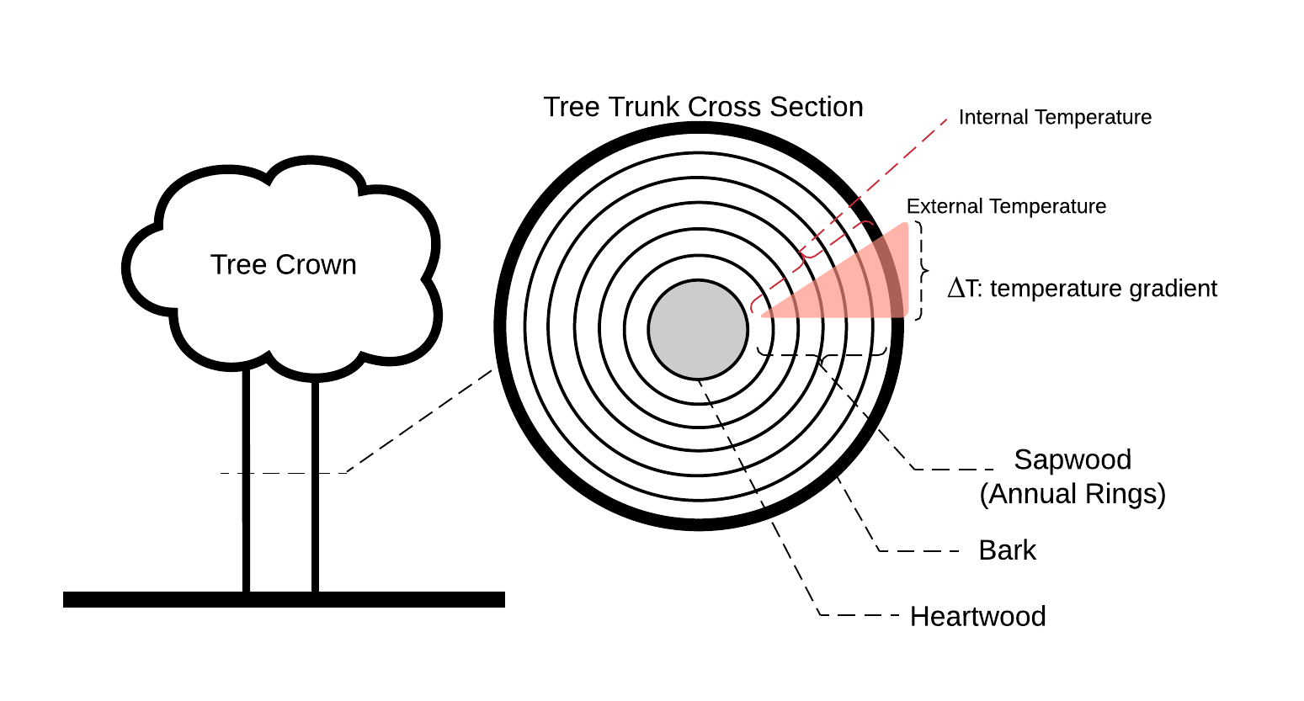

Figure 1. Tree Trunk Cross Section (Nobel, 2009).

One way to take advantage of this is phenomenon to use a Peltier cell. Peltier cells use the Seebeck effect which works on the principle that N-doped metals in series with P-doped metals will induce an electrical current when there is a temperature difference (ΔT) between the surface of the dissimilar metal’s junction.

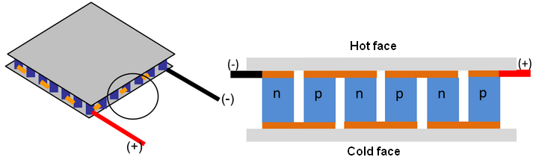

Figure 2. Thermoelectric Module and its internal structure (Source: Nesarajah, 2014).

Peltier cells are manufactured square panels that come in different sizes and quality. In order to leverage its properties with the tree temperature differential, the Peltier cell must have one side at the temperature of the core of the tree and the other side at the ambient outside temperature. The orientation of the Peltier cell was determined by comparing the temperature during the day or night and the internal tree trunk temperature.

$$T_{ Max}=|T_{Int}- T_{Ext}|$$

Equation 1. TMax used to orient the Peltier Cell.

In order to achieve the thermal equilibrium for the tree facing Peltier cell side, a widely available aluminum rod was used as aluminum is a good thermal conductor. The end was milled to a point and the rod from end to point is approximately the radius of the tree trunk at standard diameter at breast height (dbh). A pilot hole was drilled half the diameter of the rod and was hammered into the tree trunk until flush with the bark. Care must be taken not to deform the end of the rod significantly. Drilling a hole too large will introduce ambient air that reduces the thermal gradient and more importantly, may damage or kill the tree. Holes in the tree must be sealed from invading pests and leakage.

Figure 3. 38mm x 190mm Aluminum Rod with milled channel for temperature sensor wires.

The TEG was then affixed at end of the rod and connected to a microcontroller combination to collect voltage levels. A Raspberry Pi provided a means to save data to an SD-Card however, an Arduino or Analog-to-Digital converter is required to read the TEG’s analog output. The microcontrollers power was modulated by an AdaFruit Powerboost 1000c which was powered by a standard 3.7V LI-ON battery.

1. Experimental results

The first experiment consisted of one 38mm (diameter) x 190mm (length) aluminum rod placed approximately 189mm deep into a healthy 650mm diameter Ponderosa Pine. Using Equation 1 with weather forecast data the hot side was determined to face the tree. The 40mm x 40mm TEG was then thermally connected to the rod using commercial-off-the-shelf thermal paste and a heatsink was put on the outwards facing side.

|  |  |  |
| --- | --- | --- |
| **Time of Day** |  | **July 6th, 2019, JBLM, WA** |
| Day Forecast |  | 4.6° C |
| Night Forecast |  | 5.4° C |

Table 1. TMax found to be greater at night. Cold side will face away from tree.

It was then fixed in place by white household caulk. The output of the TEG was connected directly to the Arduino analog inputs. The Raspberry Pi stored the data from the Arduino in a text file every 20 minutes. All devices were powered by the Powerboost 1000c and one 3.7V battery. The energy harvesting device was then housed in a 3D printed enclosure.

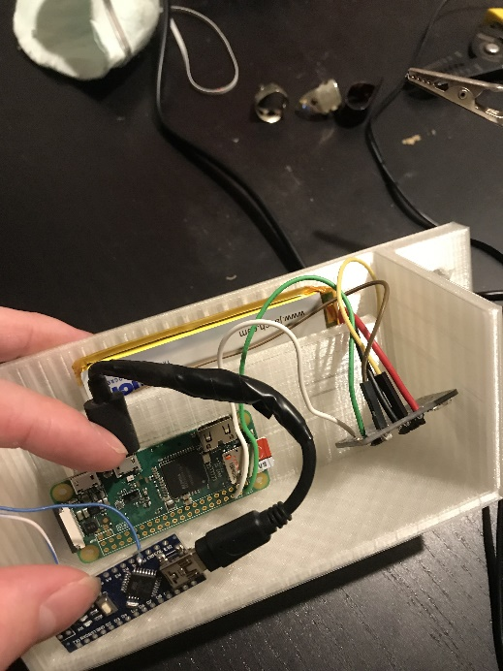 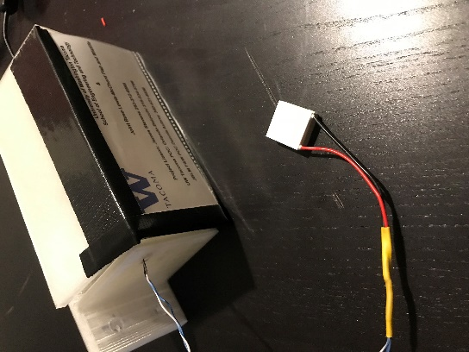

Figure 4. (a) Hardware for first experiment.

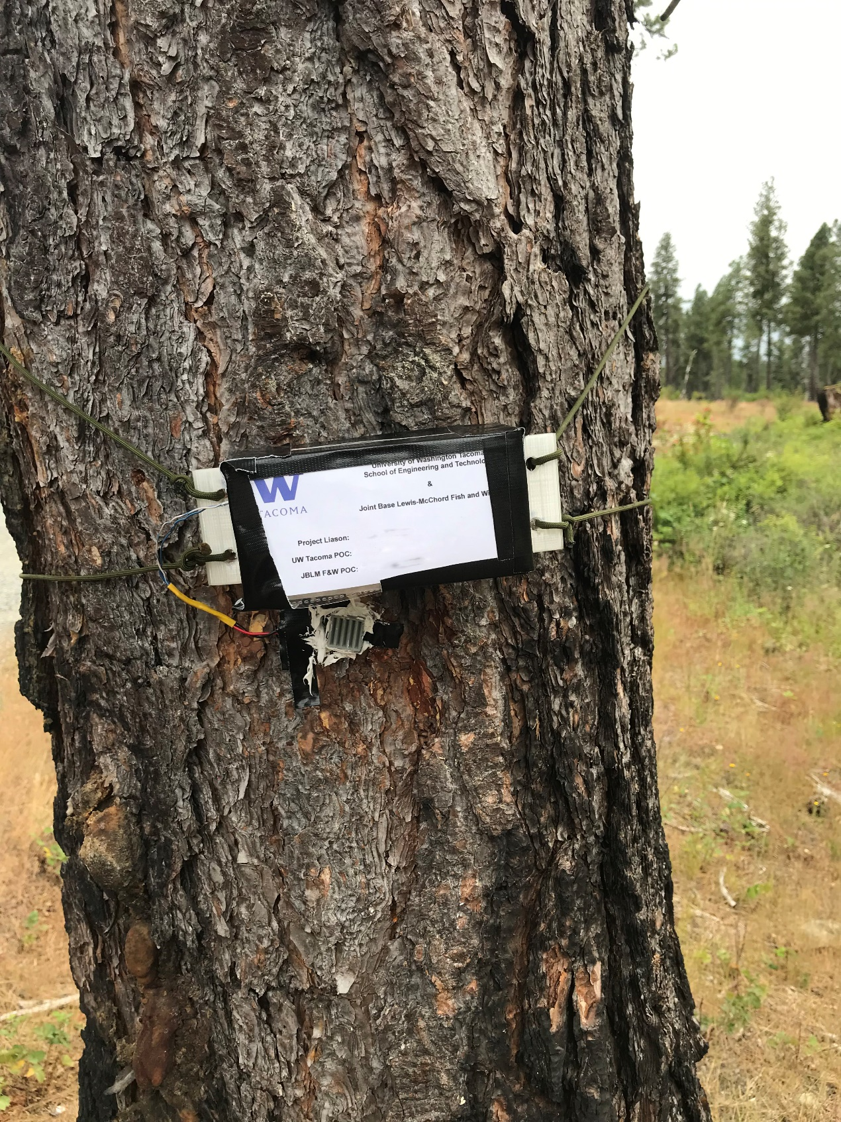

Figure 4. (b) Hardware installed for first experiment (Names & Numbers blurred).

This experiment ran for 24 hours and produced a stochastic distribution curve as the ambient temperature changed as a function of time. The produced voltage lasted for an approximate 12 hours and reached a maximum voltage of 4 mV with an overall voltage of 2mV. The hardware was limited to measuring voltage in one direction thus only produced results in the negative voltage range as the temperature dropped through the night. This experiment measured voltage on an open load.

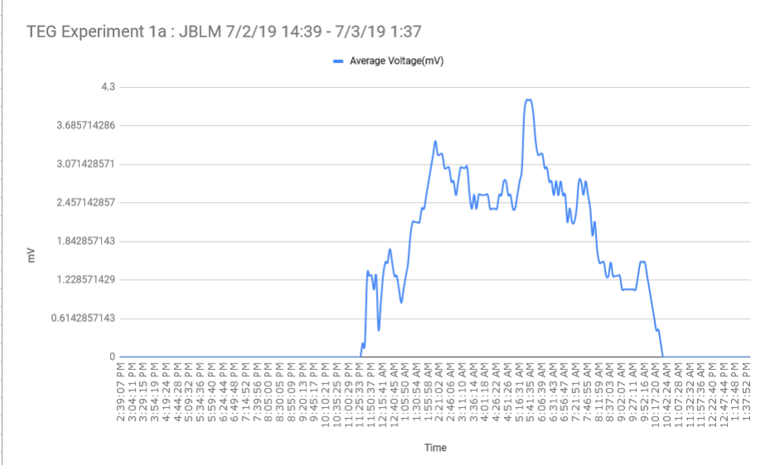

Figure 5. Voltage vs Time vs Temperature Graph of Experiment 1a.

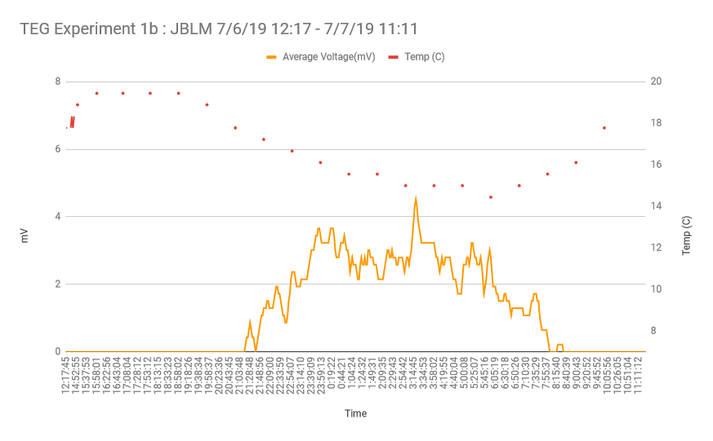

Figure 5. Voltage vs Time vs Temperature Graph of Experiment 1b.

Experiment 2 included many improvements over experiment 1. The first of many was to add a manual power switch. Secondly, temperature sensors near the tip of the aluminum rod and on the outside of the tree trunk were added. The rod was milled with a channel to fit the sensor and then sealed. Another improvement was to use thermal glue instead of thermal paste which has adhesion properties and removed the need for caulk. Also, the heatsink was left off the TEG which was now sized 10mm x 10mm.

A 555 timer was added which cycles the Raspberry Pi’s power at an interval of approximately 20 minutes to improve battery life. The addition of a Real Time Clock (RTC) was added to keep proper time on the Raspberry Pi as it cycled off and on. The Arduino was replaced with an Analog-to-Digital Converter (ADC) chip. The ADC also rectifies the voltage allowing the measurement of voltage in both positive (day) and negative (night) directions. An Operational Amplifier (OpAmp) was added between the TEG and the ADC for more precise voltage readings. The last change is the voltage measurements are made over a 1-Ohm load.

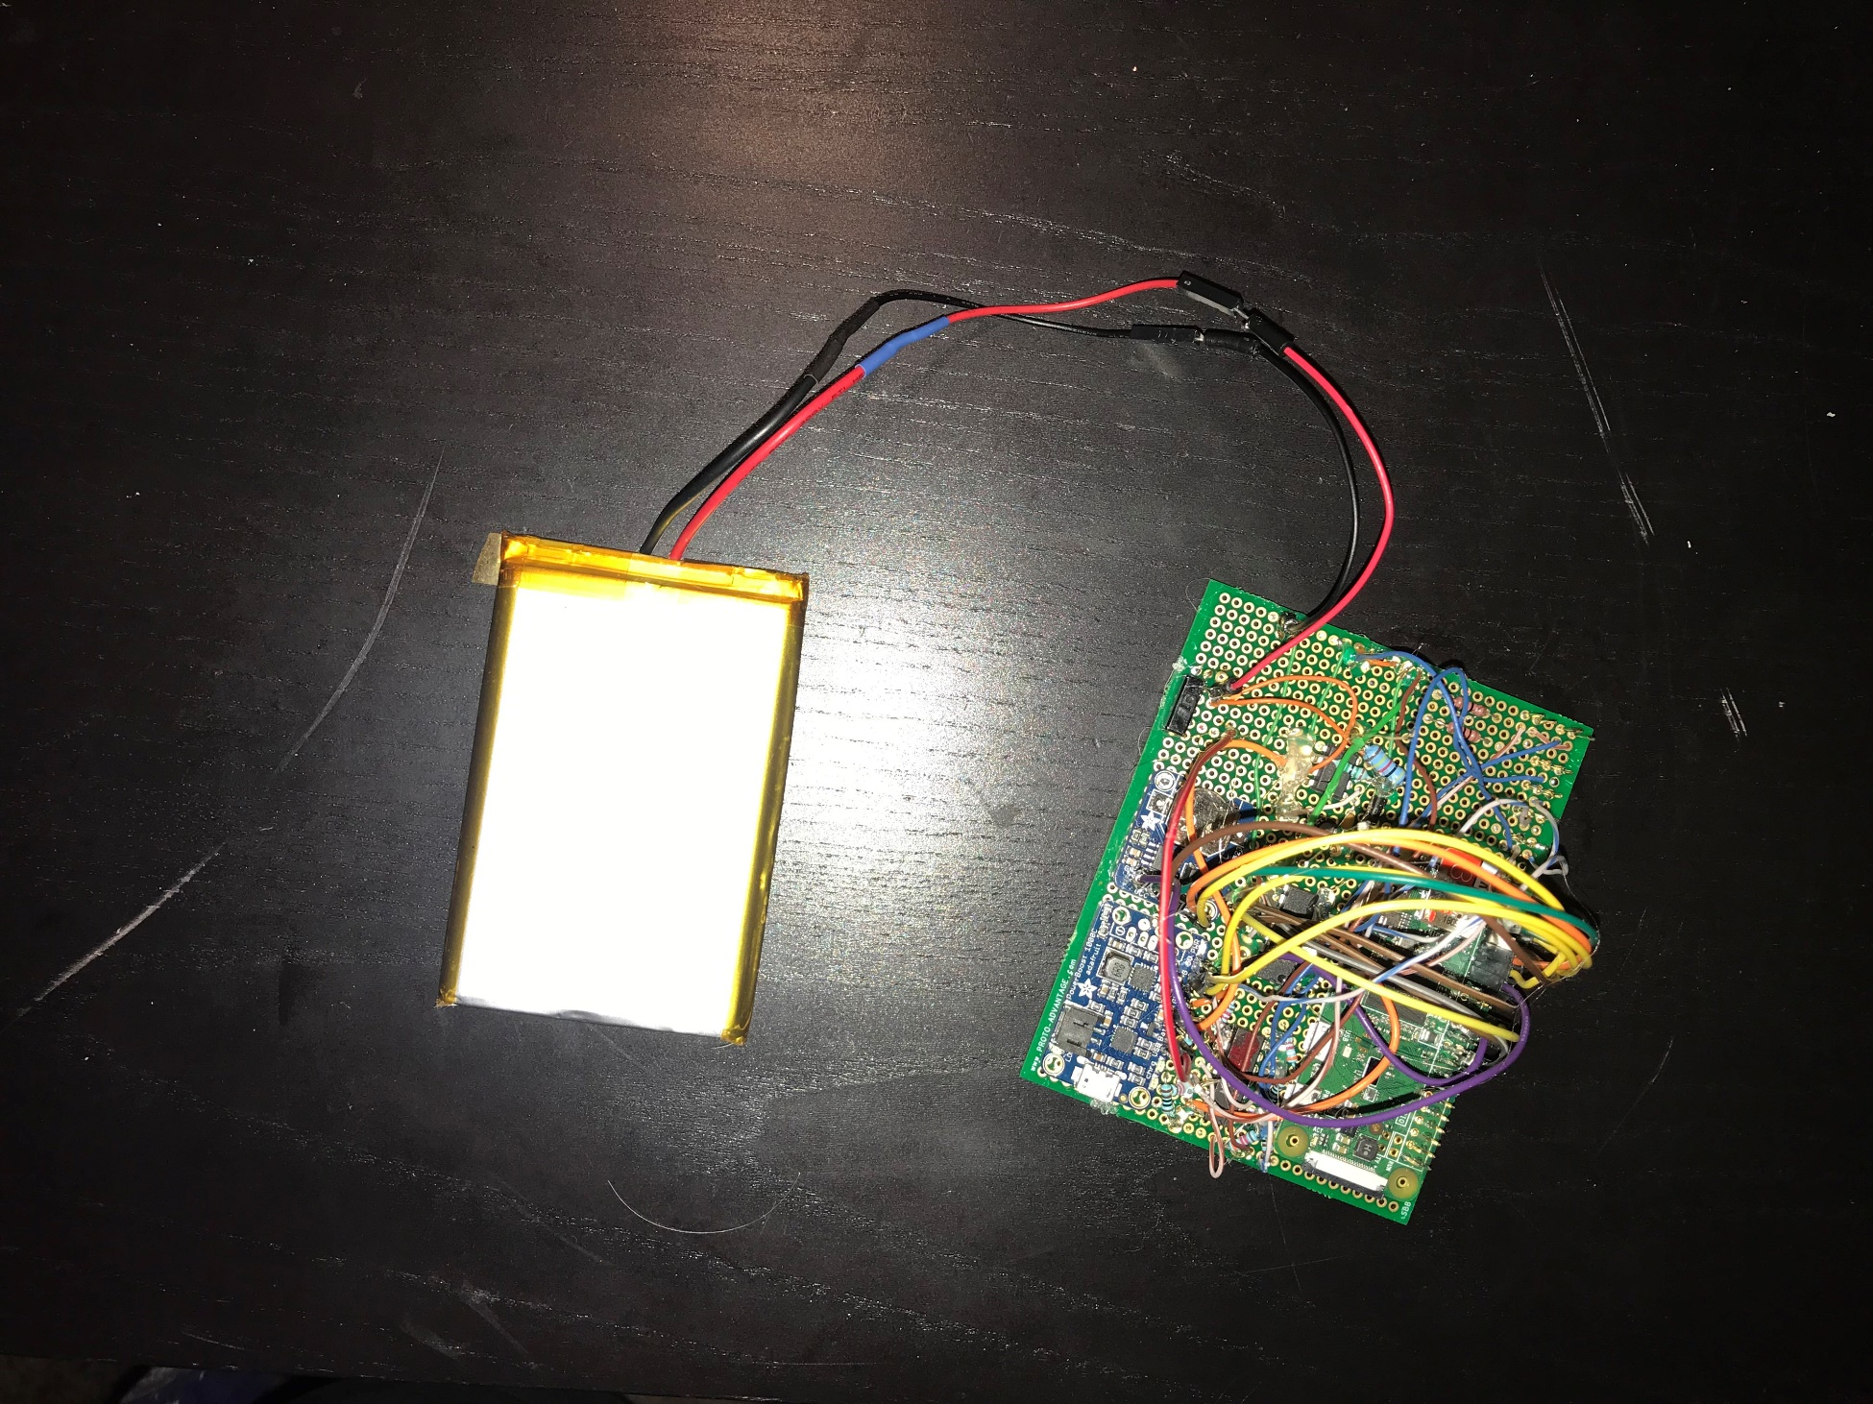

Figure 6. Hardware of Experiment 2: Raspberry Pi, RTC, 555 Timer, On-Off Switch, Powerboost 1000c, OpAmp, ADC, 1 Ohm Resistors.

Experiment 2 was installed in an adjacent ponderosa pine matching the approximate size and health of the first tree. Tree 2 also had an equal amount of sun and shade however the energy harvester was installed south facing as opposed to the first which was north facing. Using the method from Table 1 it was determined to face the hot side away from the tree as the temperature difference would be greatest during the daytime.

Figure 7 below shows the internal temperature of the tree is consistent with previous research as the tree maintains an internal temperature of approximately 21.4° Celsius. In future experiments it would be beneficial to install the TEG a day prior to turning it on so that the rod may equalize with the tree’s temperature. This was not done here so any reading before 18:00 on 8/1/2019 should be disregarded.

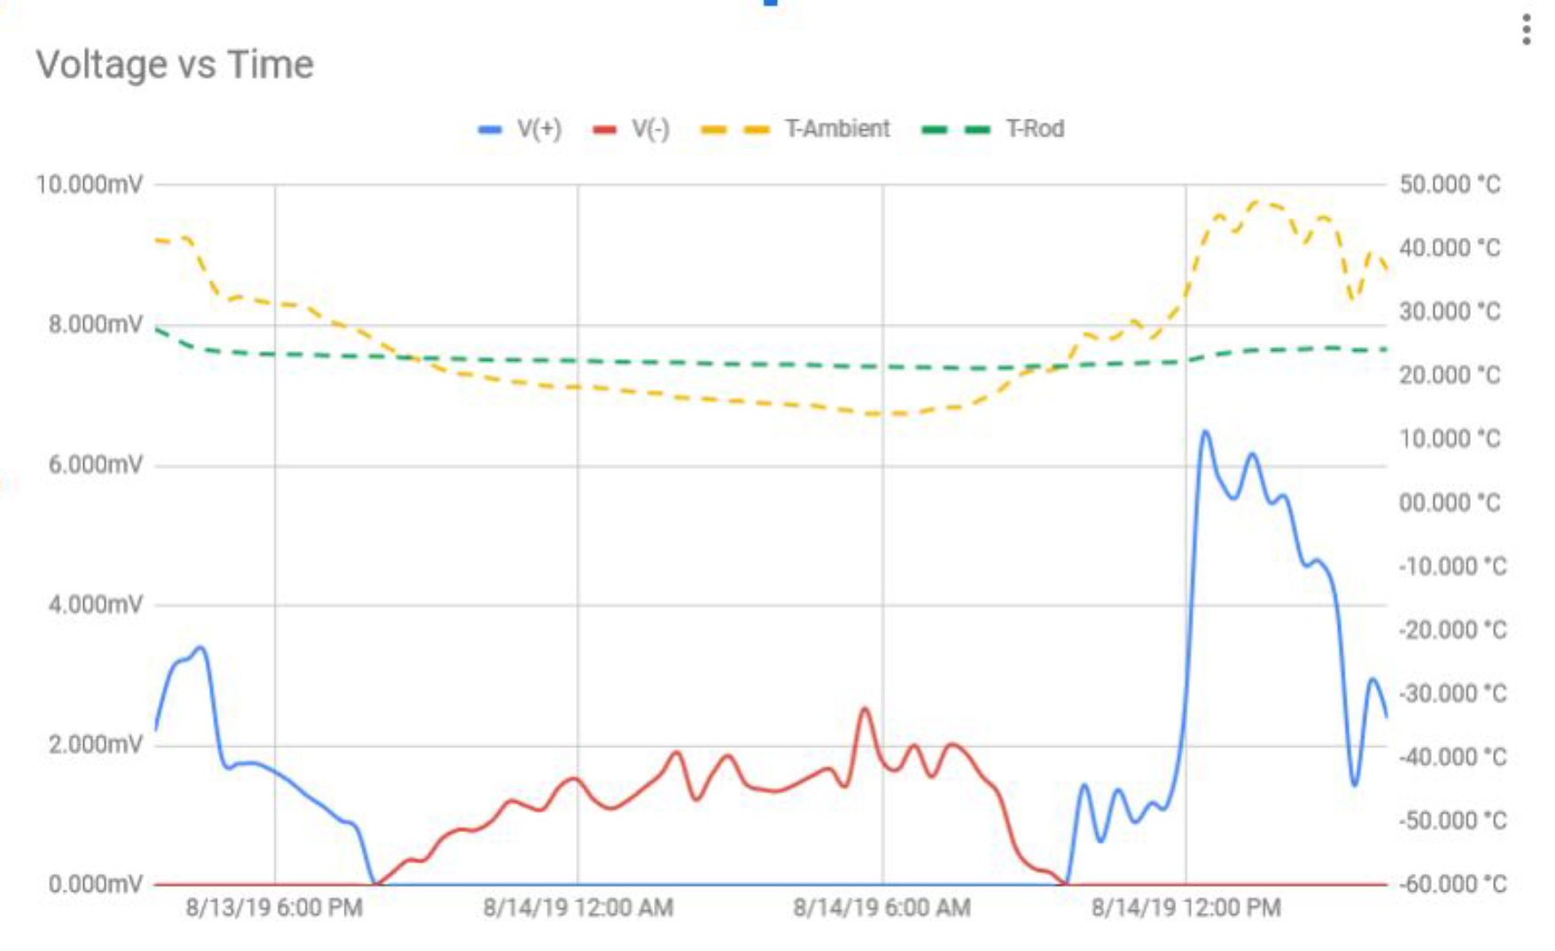

Figure 7. Experiment 2.

The maximum voltage measured during daytime was 6.8mV with an average of 5mV. The nighttime measurements yielded a maximum voltage reading was 2.8mV with an average of 1.5mV. There appears to be a relationship between the area under the voltage curve and the area of the temperature gradient. A more stringent mathematical analysis should be done on this possible relationship. If most or all tress around the globe maintain this inner temperature than the amount of power able to be drawn by the energy harvesters is based on the temperature relative to 21.4° Celsius. The larger the difference the larger the voltage will be.

1. Conclusions and possible future directions

The results of both experiments were promising considering the simplistic apparatus design. With a more efficient design and better materials the results should see some improvement. Future research should consider the characteristics of each tree species available and the environment they inhabit. Tree density, fluid-dynamics, size, and temperature difference are among some properties to consider.

Currently available TEGs vary in sizes and efficiency. Future experiments should test these against varying diameters of rods. Surface area vs resistance should be researched. Depth increased the temperature difference between the tree and the ambient temperature (Protásio, 2018). Thus, one might consider an aluminum rod that has TEG’s in series, inserted at intervals inside the tree to increase the yield. Custom design work will need to be done in order to make sure the rod and all attached components stay undamaged during the installation process. A problem may arise where there will not be enough compartmentalization between each TEG and thus reduces the efficacy. However, if depth is a factor this may be worth exploring rather than a single TEG at the end of the rod.

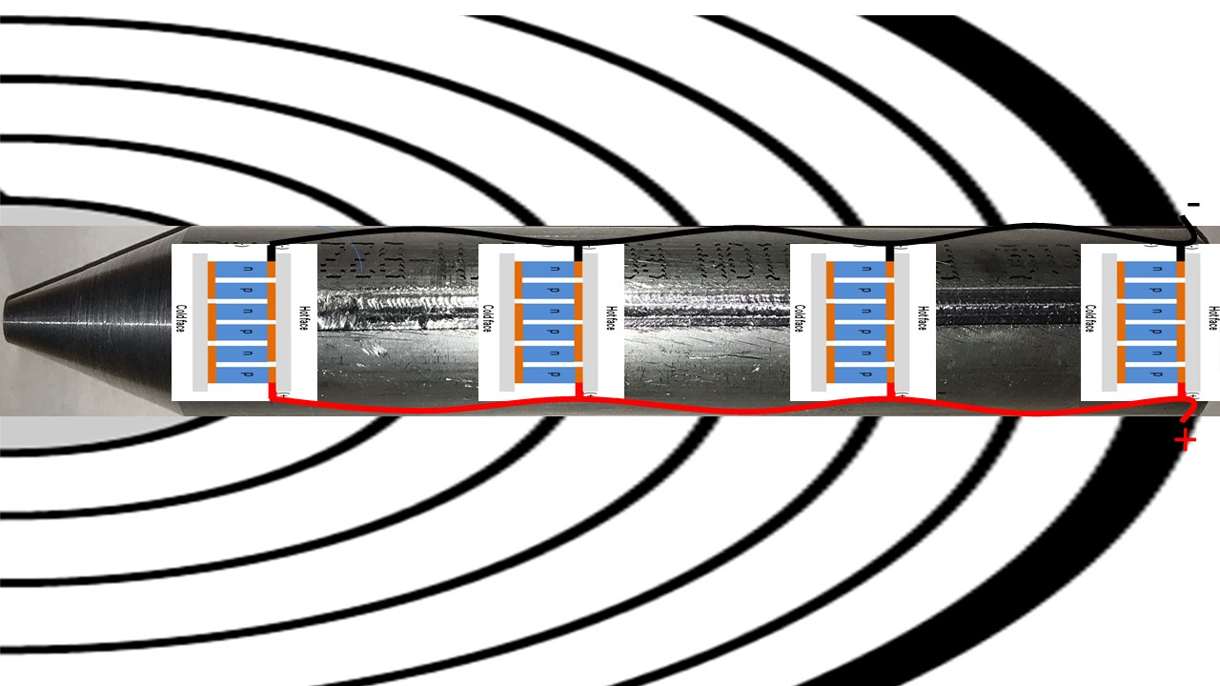

Figure 8. Possible Future Experiment 1.

Research was conducted into thermocouples as they have a cylindrical shape more advantageous to the research at hand; however, these are designed to operate as temperature sensors rather than generators and are not as efficient as TEGs in voltage generation. However, thermocouple wire is available and could be useful for a proof-of-concept design as illustrated in Figure 9.

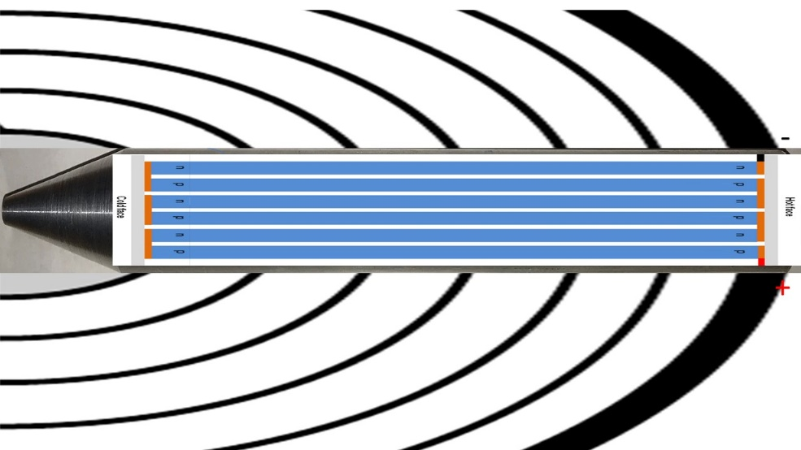

Figure 9. Possible Future Experiment 2.

The second experiment resulted in a maximum of 5mV across a 1-ohm load which is not enough to power current day sensors and transmit the data. The next step is to use adapted circuits to reach the required threshold of usable power. A Joule-Thief circuit will store the energy in capacitors and release it in intervals allowing for higher potentials. Impedance matching and capacitor leakage will be the main hurdles to overcome.

If the energy harvester is the sole source of power, given the current data, it may be possible to power sensors with extremely low power communication chips that communicate with a central node. This central node would likely be powered by more conventional means and transmit for a longer distance. If energy harvesting is not enough for the given sensor nodes, an energy-harvesting device may be used to trickle charge a battery at such a rate to sustain the battery long term.

Lastly, another viable option is to install multiple energy harvesters in a single tree and connect them in series. More research needs be done regarding tress ability to sustain these rods and mechanisms.

References

Cleonilson Protásio de Souza, Fabrício B. S. Carvalho, Filype A. N. Silva, Hening A. Andrade, Nathália de V. Silva, On Harvesting Energy from Tree Trunks for Environmental Monitoring, 2018

Helliker, Brent R. and Richter, Suzanna L. Subtropical to boreal convergence of tree-leaf temperatures.  Nature.  Vol 454|24 July 2008| doi:10.1038/nature07031

Nobel, Park S. Physicochemical and Environmental Plant Physiology. URL: https://books.google.com.br/books?id=3wMBwxGIqDIC, 2009 Elsevier Science.

Nesarajah, M.; Felgner, F.; Frey, G.: Modeling and Simulation of a Thermoelectric Energy Harvesting System for Control Design Purposes. Proceedings of the 16th International Conference on Mechatronics - Mechatronika (ME), IEEE, Brno, Czech Republic, pp. 170-177, Dec. 2014. <DOI: 10.1109/MECHATRONIKA.2014.7018254>.